
ST ANDREW’S JUNIOR COLLEGE
Preliminary Examinations
Higher 1

H1 Geography 8834/01
Paper 1 22 August 2024
INSERT 3 hours

READ THESE INSTRUCTIONS FIRST

This insert contains all the Resources referred to in the questions.

This document consists of 9 printed pages
[Turn over

Resource 1 for Question 1

Map of East Coast Park with sample sites

East of East Coast Park

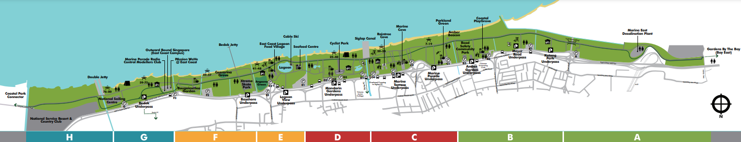

West of East Coast Park

The entire length of East Coast Park is 15 km.

= Sample site
A, B, C D, E, F, G, H = Zones within East Coast Park
Resource 2 for Question 1

Four of the sample sites
[Turn over
Raintree Cove | East Coast Lagoon Food Village
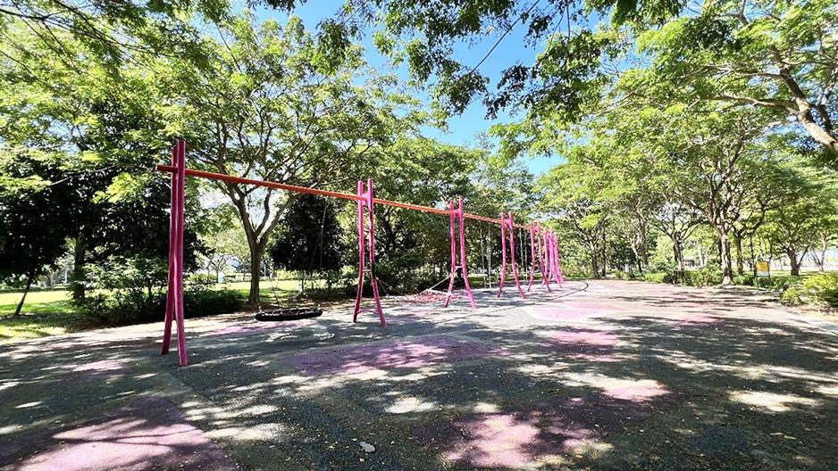 | 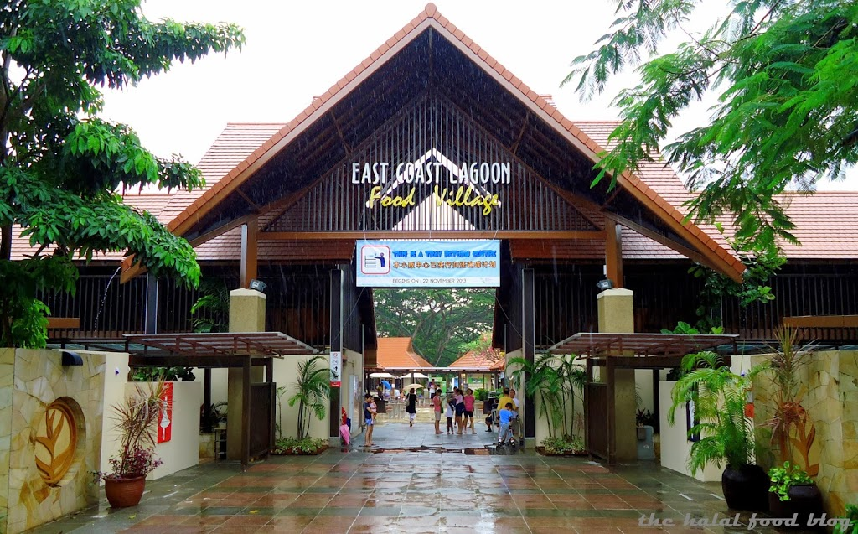
Amber Beacon | Marina East Desalination Plant
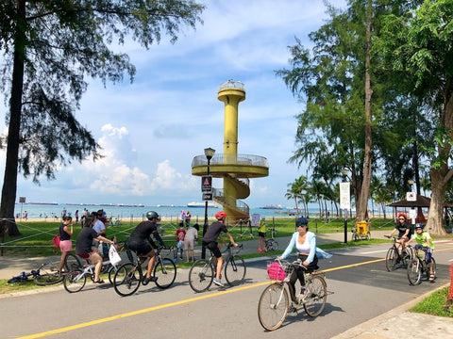 | 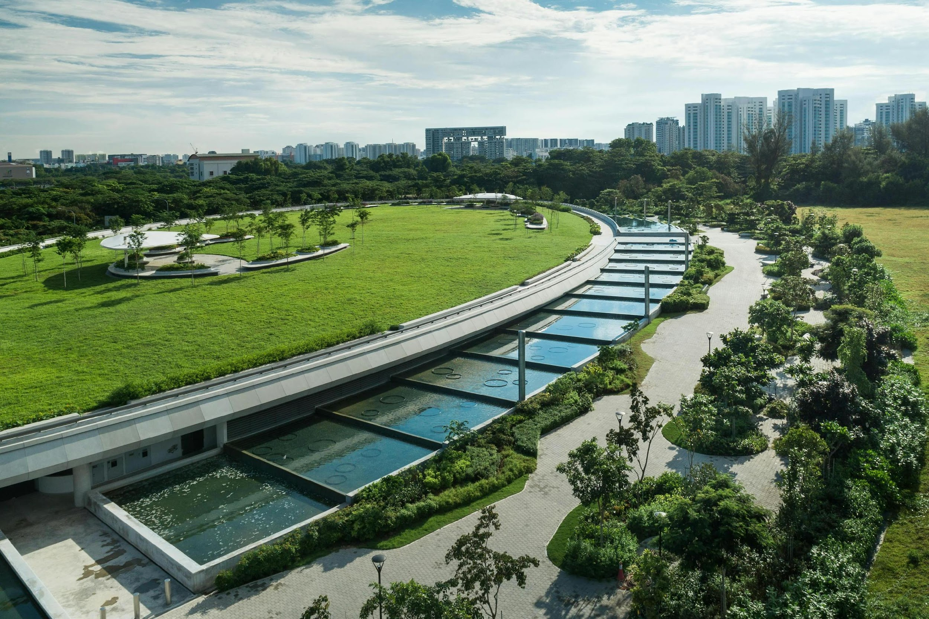

Resource 3 for Question 1
Selected results of the questionnaire survey

1. Frequency of Visits to East Coast Park:
- Daily: 10%
- Weekly: 35%
- Monthly: 25%
- Rarely: 20%
- Never: 10%

2. Main Activities Engaged in at East Coast Park:
- Walking: 50%
- Sitting and relaxing: 30%
- Socialising with friends/family: 25%
- Exercising (e.g., tai chi, stretching): 20%

3. Ease of Access to East Coast Park:
- Very easy: 40%
- Easy: 35%
- Neutral: 15%
- Difficult: 5%
- Very difficult: 5%

4. Specific Facilities Rated:
 | Seating areas | Restrooms | Walking paths | Signage and information
Very satisfied | 25% | 15% | 30% | 10%
Satisfied | 45% | 35% | 40% | 35%
Neutral | 20% | 25% | 15% | 30%
Dissatisfied | 5% | 15% | 10% | 15%
Very dissatisfied | 5% | 10% | 5% | 10%

5. Perception of Safety at East Coast Park:
- Very safe: 30%
- Safe: 45%
- Neutral: 15%
- Unsafe: 5%
- Very unsafe: 5%

6. Comfort of Visiting East Coast Park:
- Very comfortable: 25%
- Comfortable: 40%
- Neutral: 20%
- Uncomfortable: 10%
- Very uncomfortable: 5%

7. Suggestions for Improvement (You may select more than one option):
- Increase the number of seating areas: 35%
- Improve restroom facilities: 30%
- Enhance lighting in certain areas: 25%
- Provide more elderly-friendly exercise equipment: 20%
- Offer more shaded areas: 40%
- Better maintenance of walking paths: 15%
Resource 4 for Question 2

City Liveability Index in March 2023

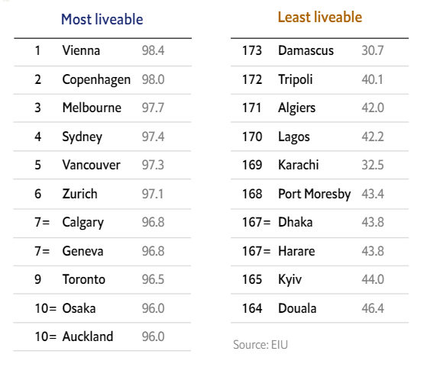
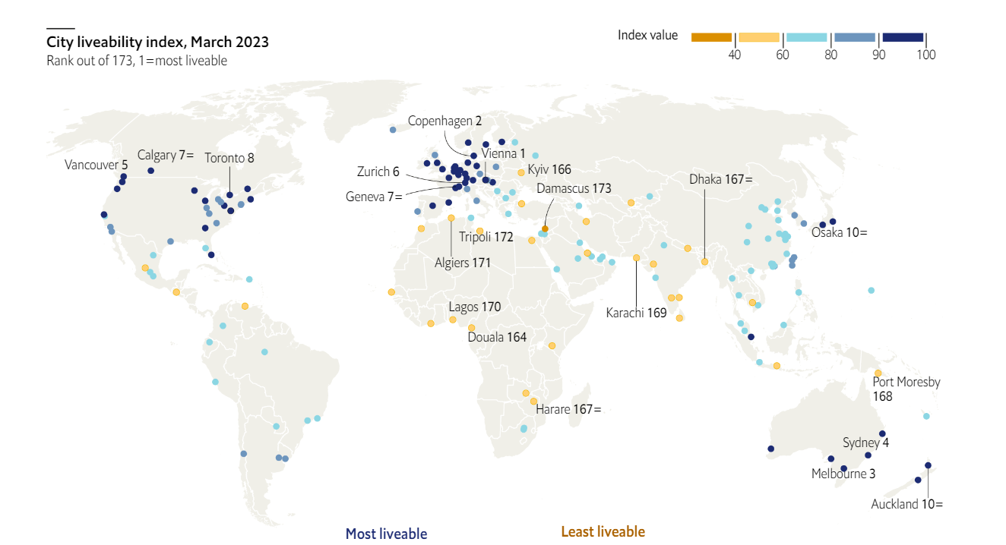

[Turn over
Resource 5 for Question 2

Slum in Kibera, Nigeria

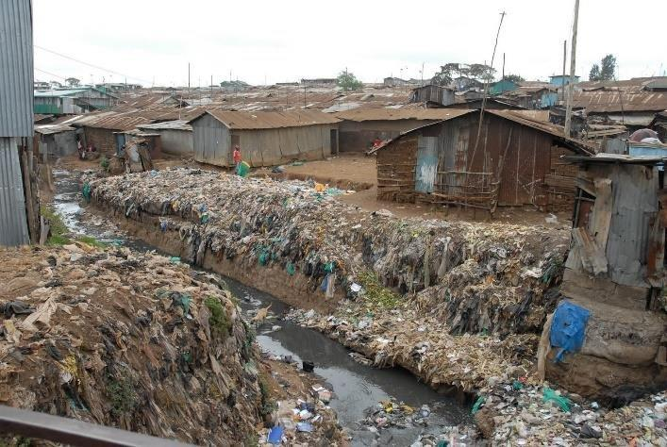
Resource 6 for Question 2

Indicators of sustainability of Pittsburgh, a city in the United States of America and the United States of America 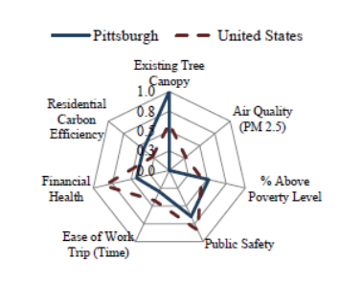

Note: 1.0 denotes the maximum score that can be awarded for each indicator; 0.0 denotes the minimum score that can be awarded for each indicator. For air quality, a higher score means better air quality.

[Turn over
Resource 7 for Question 3

Cross-section from the Mediterranean Sea to the Arctic Ocean showing typical glacial and interglacial conditions

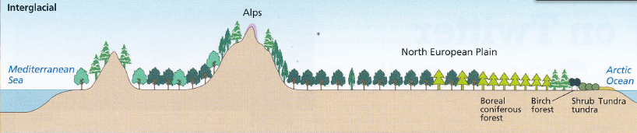
steppe shrub tundra, shrub tundra, tundra, polar desert, local montane zone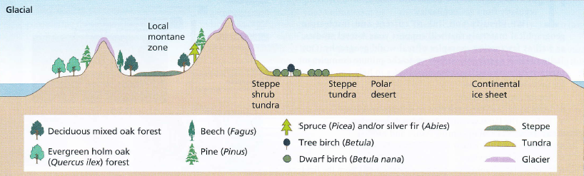

Tundra: A vast, flat, treeless Arctic region where the subsoil is permanently frozen.

Steppe shrub tundra: A very cold dry-climate vegetation type consisting of mostly treeless open herbaceous vegetation.

Shrub tundra: Abundance of medium small and small shrubs, including 1-2 m tall shrubs.

Polar desert: Largely barren environments, comprising permanent, flat layers of ice.

Local montane zone: Zone of relatively moist cool upland slopes dominated by large coniferous trees.

Resource 8 for Question 3

Map of the ice cap and glacier limits on Disko Island, Greenland

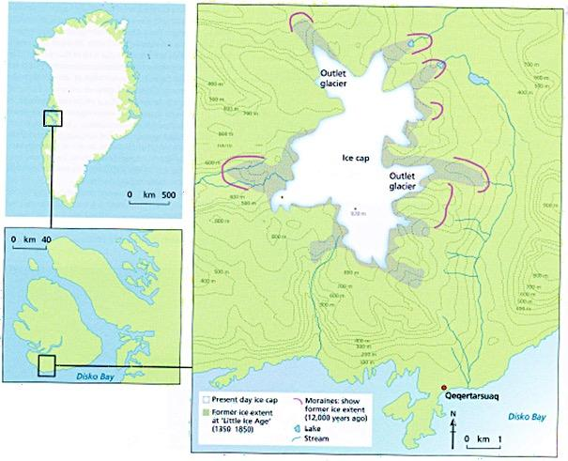

Resource 9 for Question 3

Graphical representation of the ice coverage (km²) on Disko Island, Greenland

